Lab 3: Analyzing Types of Web Application Attacks

1 SQL Injection Basics

* 1. Using WebGoat for SQL Injection

1. Launch the Kali VM and log in with credentials provided.
2. Once log in launch the terminal
3. Enter the following command: sudo docker run --rm -it webgoat/goatandwolf

Enter password when prompt.

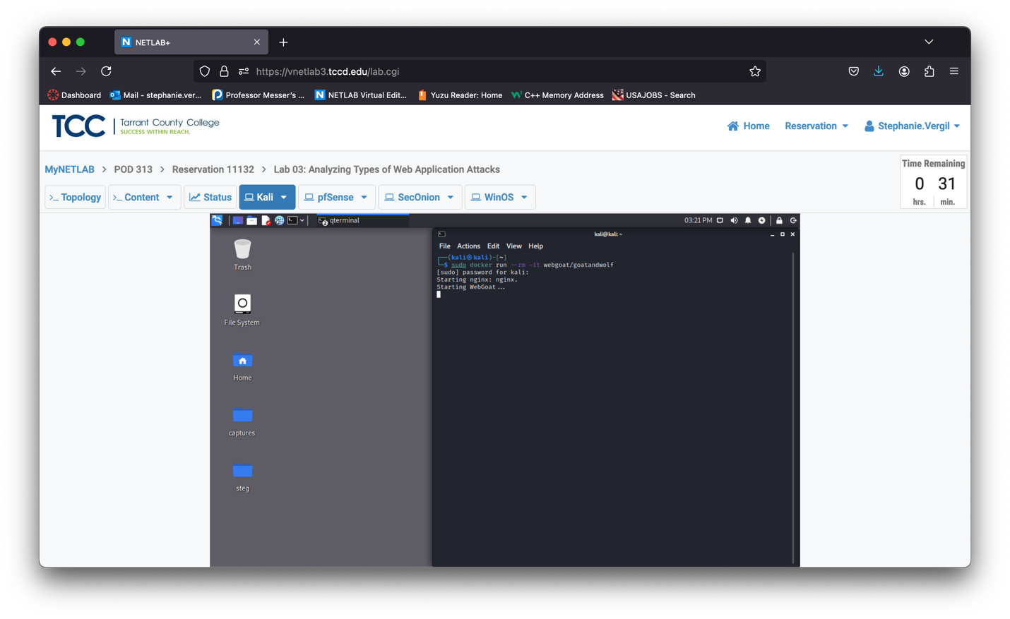

1. When everything is ready it should come to a pause on the rolling massage as shown bellow

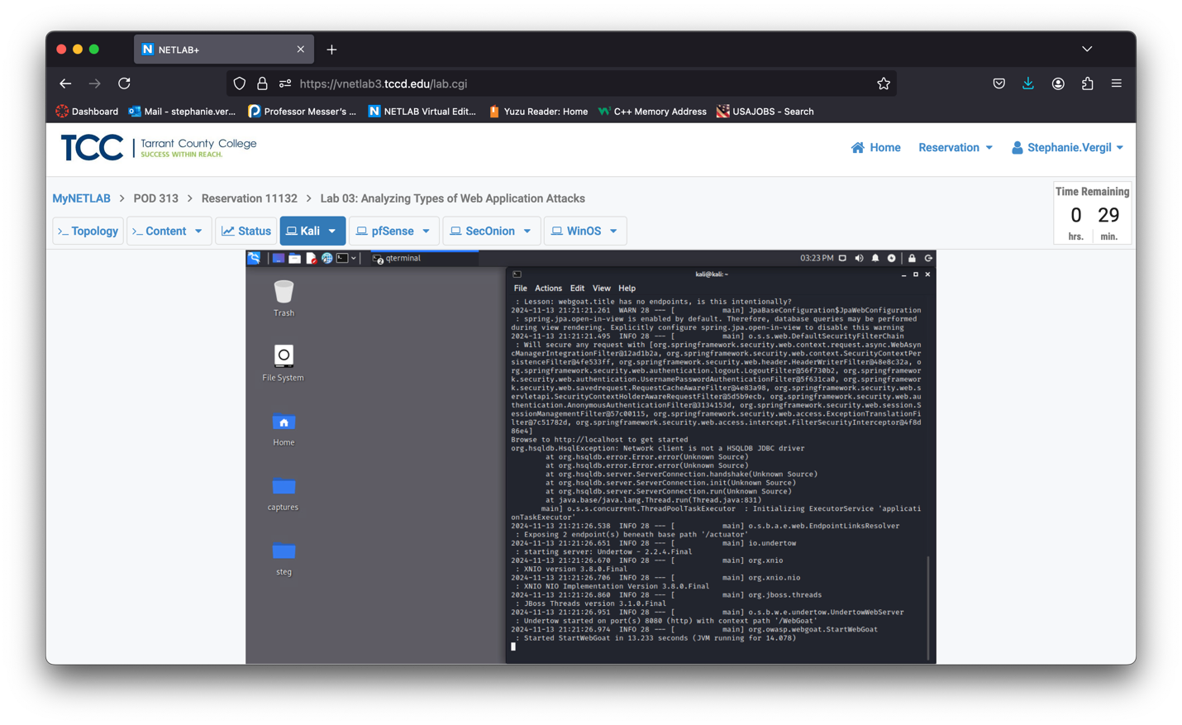

1. Launch web browser
2. In the address bar enter: <http://172.17.0.2:8080/WebGoat/login>

It is case sensitive.

1. You will see the WebGoat login page, click Register new user, and then type guestuser as the username and guestuser as the password check the box, and click Sign up.
2. Once signed up, you will be brought to this page.

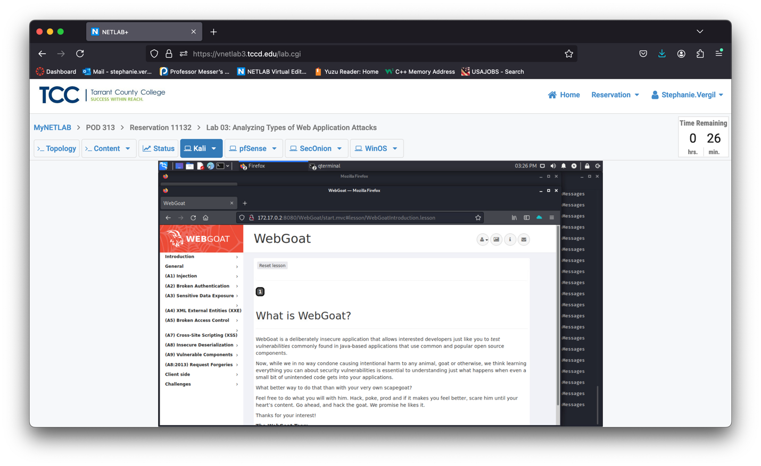

1. Click on the (A1) Injection, then SQL Injection (Intro); you will then see the lessons in the right pane from 1 to 13.
2. We will be jumping directly to lesson 9. Click on the number 9 here.

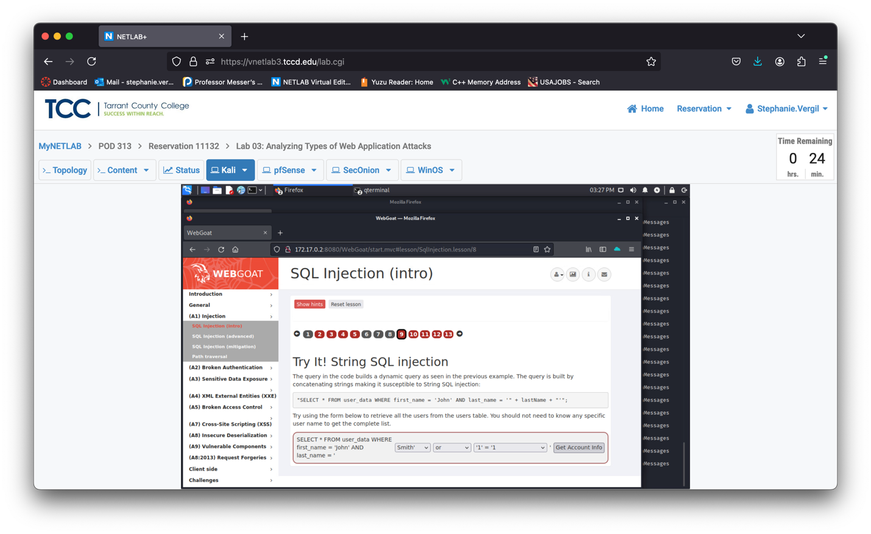

1. In lesson 9, you will see this screen. After reading the instructions, we understand that the challenge is to select the malicious SQL command to retrieve all the users from the users’ table. In the SQL query, notice the part where last_name = ‘ ends with a single quote ‘. This means if we were to craft a malicious SQL query, we would want to close the single quote first. So, we select Smith’ in the first dropdown box.
2. Next, we will leave the or untouched because it is the key part of the malicious query. And again, notice the single quote after 1=1. We should correct the syntax, so we are going to select ‘1’ = ‘1 from the dropdown box.



1. Clicking the Get Account Info button retrieves all the users from the user_data table. The red square shows the forged malicious SQL query.

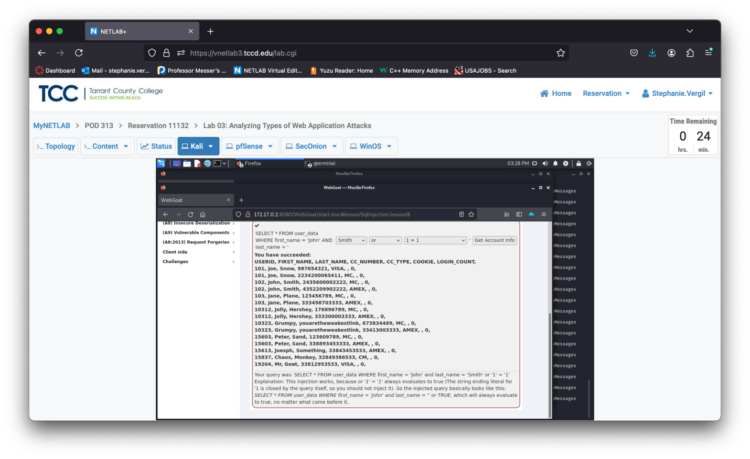



1. Now, click on lesson 10. In this lesson, we are asked to exploit two fields: the first one is Login_Count, and the second one is User_Id. Since we now have two fields and we do not know which one is susceptible to SQL injection, we will have to try it in both fields. Let’s begin with the Login_Count, type 0 or 1=1 and fake id as shown in the screenshot below, and then click the Get Account Info button.
2. The result shows it is not correct.

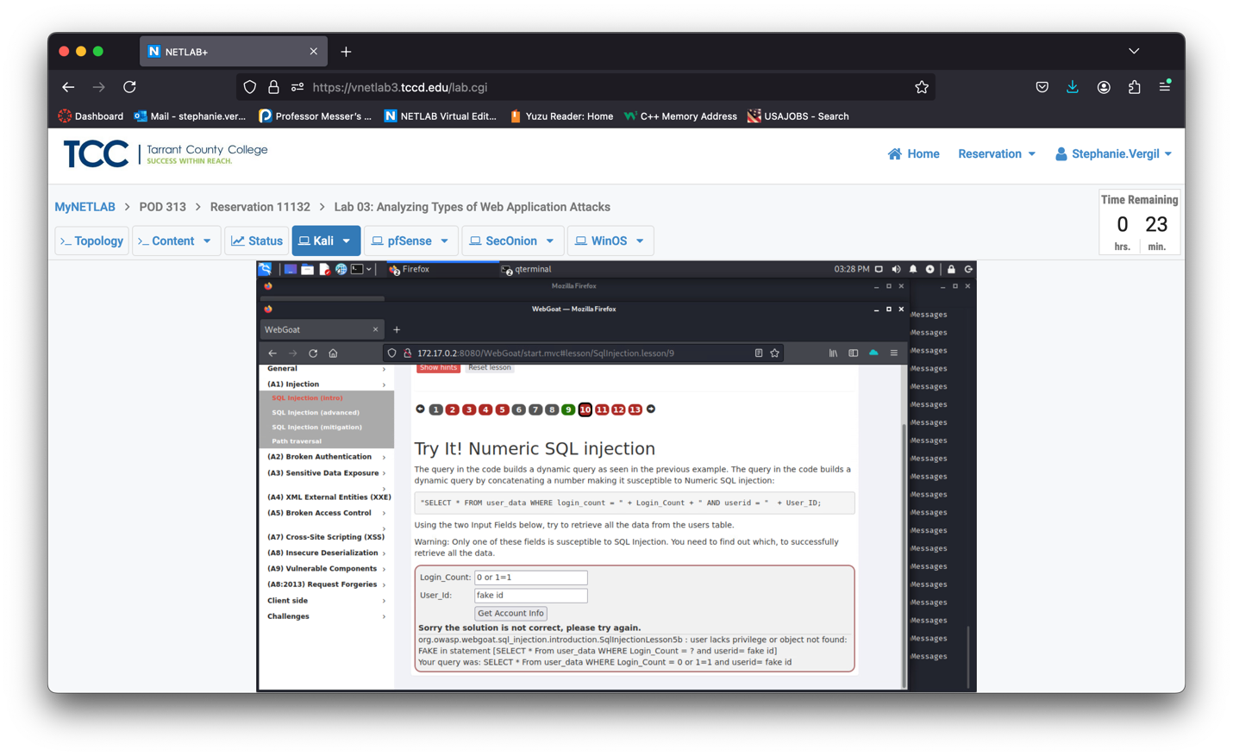

1. Try to exploit the User_Id. Change Login_count to 11 and User_Id to 0 or 1=1 as shown in the screenshot below, then click Get Account Info.
2. We now have the correct solution.

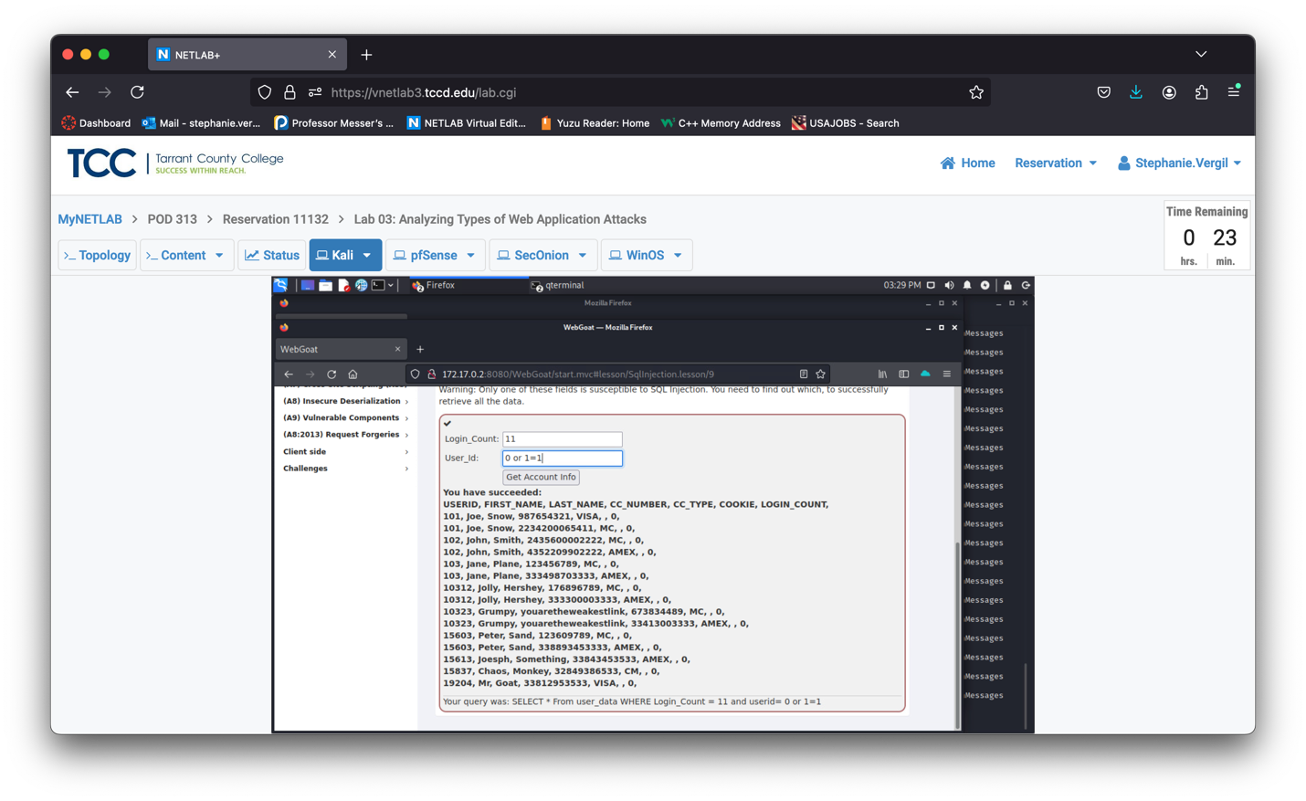

1. Let’s now check a challenge and have a taste of what SQL injection could look like on a website. First, close the web browser, and click the top-left corner to bring up the Applications menu, then type burpsuite. In the result list, click burpsuite to launch the software.
2. Ensure that Temporary project is selected and click Next.

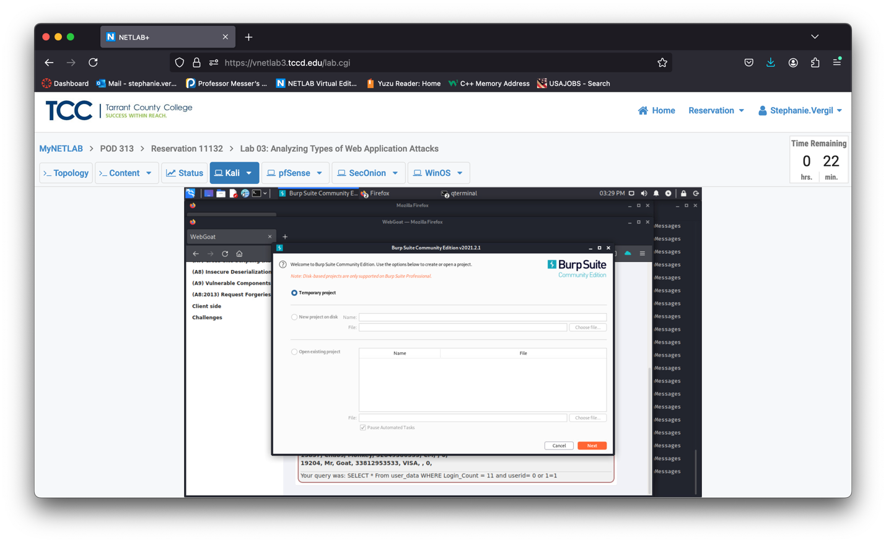

1. Then, click Start Burp on the next screen. If prompted for a new version, click OK to acknowledge it.

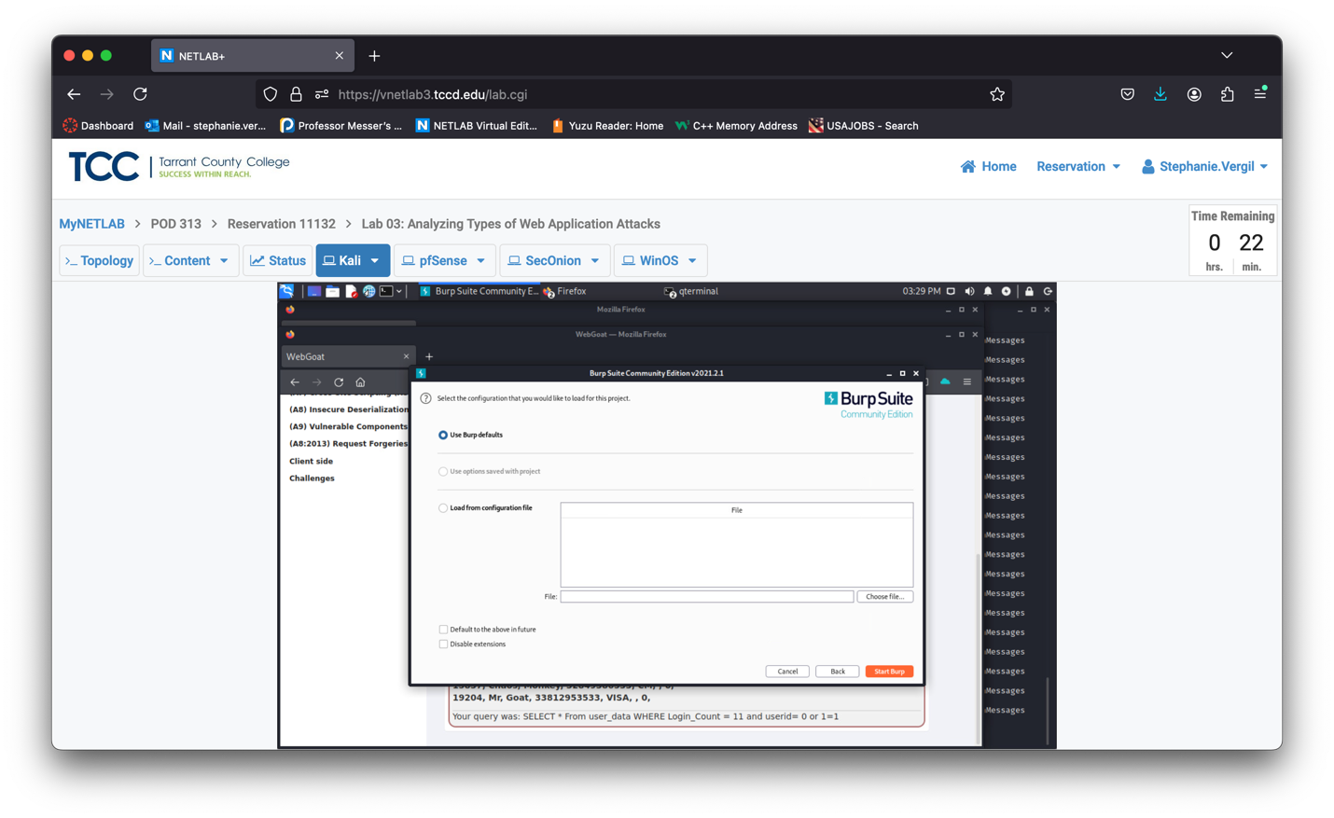

1. When Burp Suite starts, click Proxy to switch to the tab.

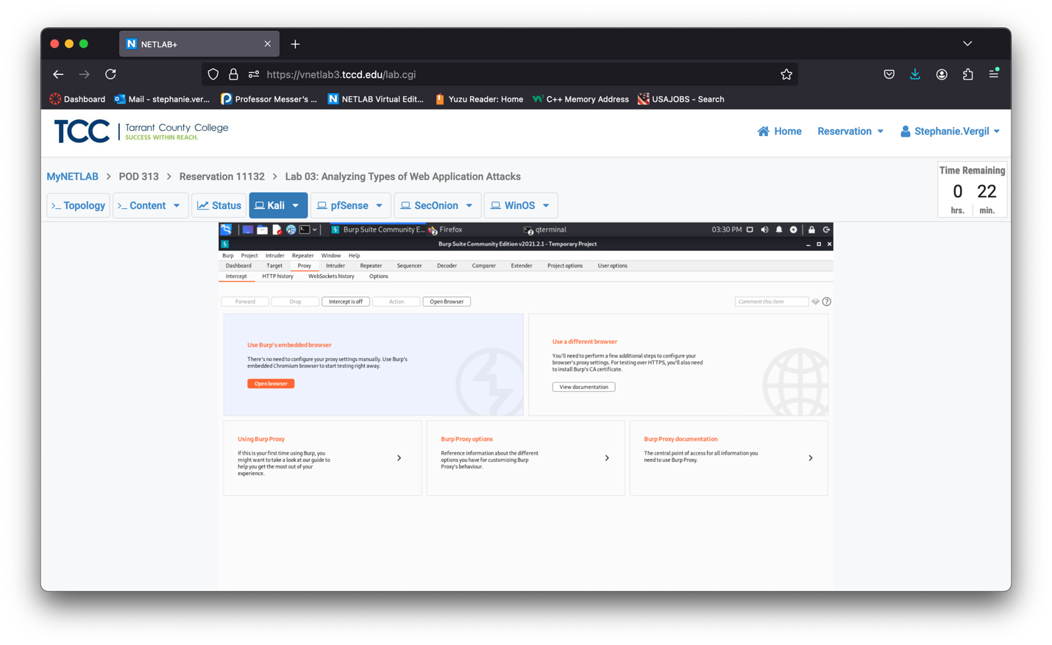

1. Then click Intercept is on to turn interception off. At last, click the Open Browser button.
2. In the newly opened browser, go to the http://172.17.0.2:8080/WebGoat/login page again, and log in using the guestuser login you just created. When prompted to save the password, click Never.

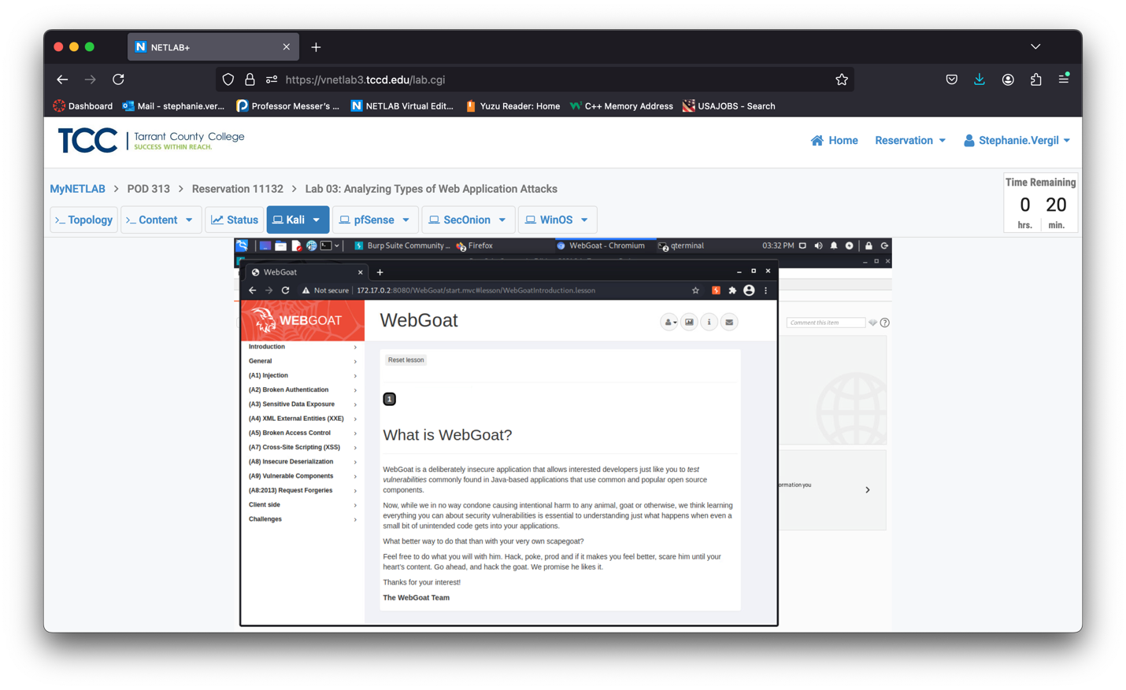

1. If prompted with Authentication required (or choose password for new keyring), click Cancel. Click Cancel again when it prompts for the second time.
2. After you log in, click the challenges, then Without password.
3. In the browser, fill in the username Larry and password fakepassword, and click Log In. This will create a POST request and send it to the WebGoat website.

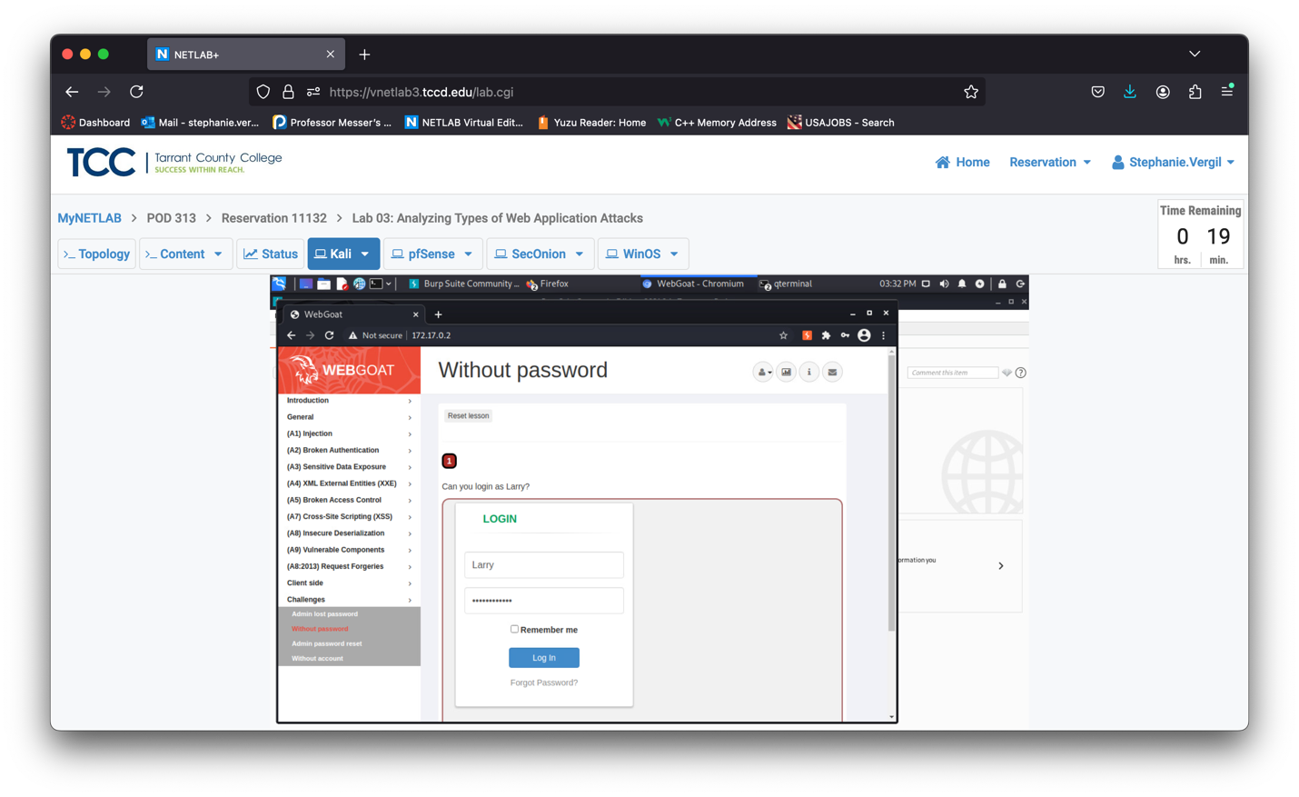

1. Switch back to the Burp Suite window, if you are not already, click on the HTTP history tab. In the table header, click on Method twice to reorder the list in descending order, find the POST request that has the URL of /WebGoat/challenge/5

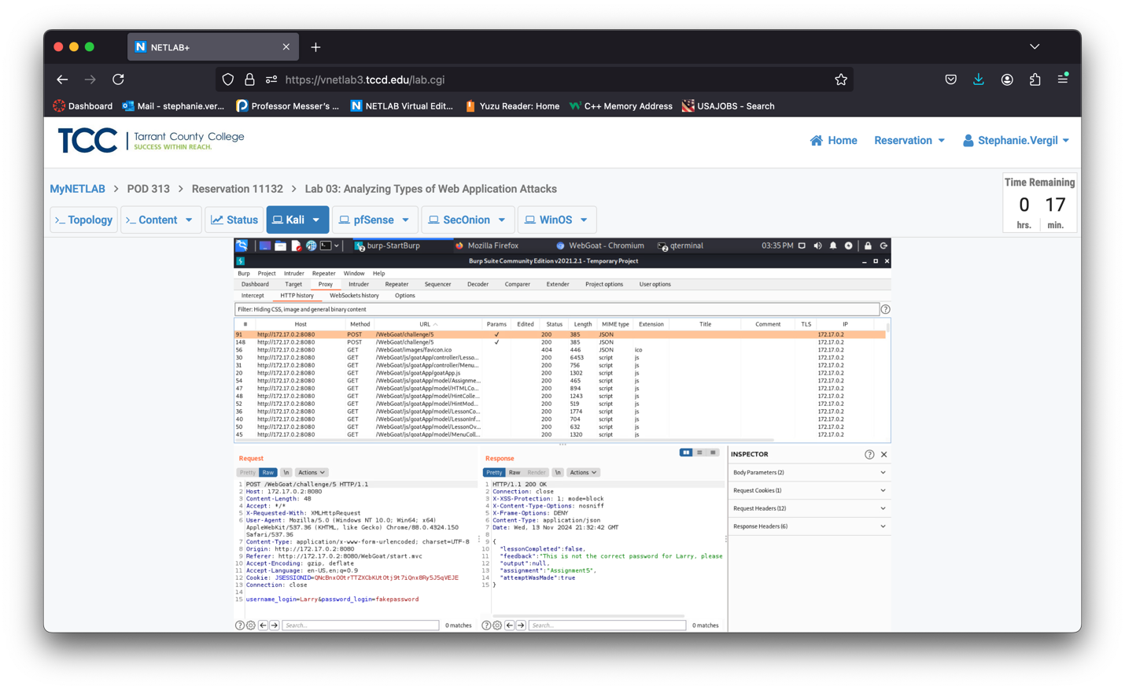

1. Right-click on that POST entry, and choose to Send to Repeater.

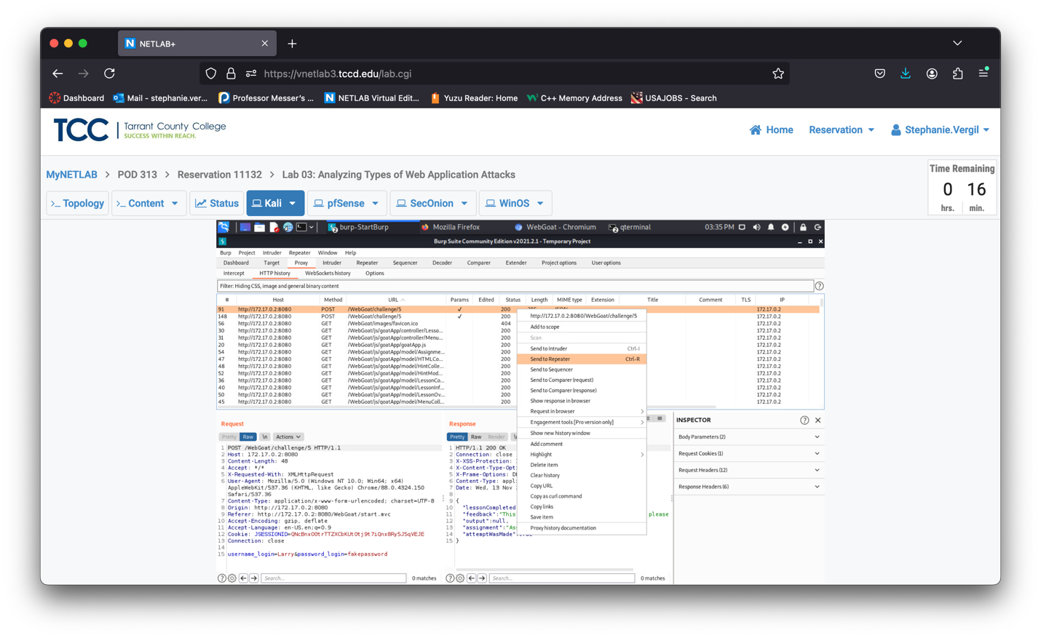

1. The Repeater will light up for a few seconds. Let’s click the Repeater tab. You will see a screen like this:

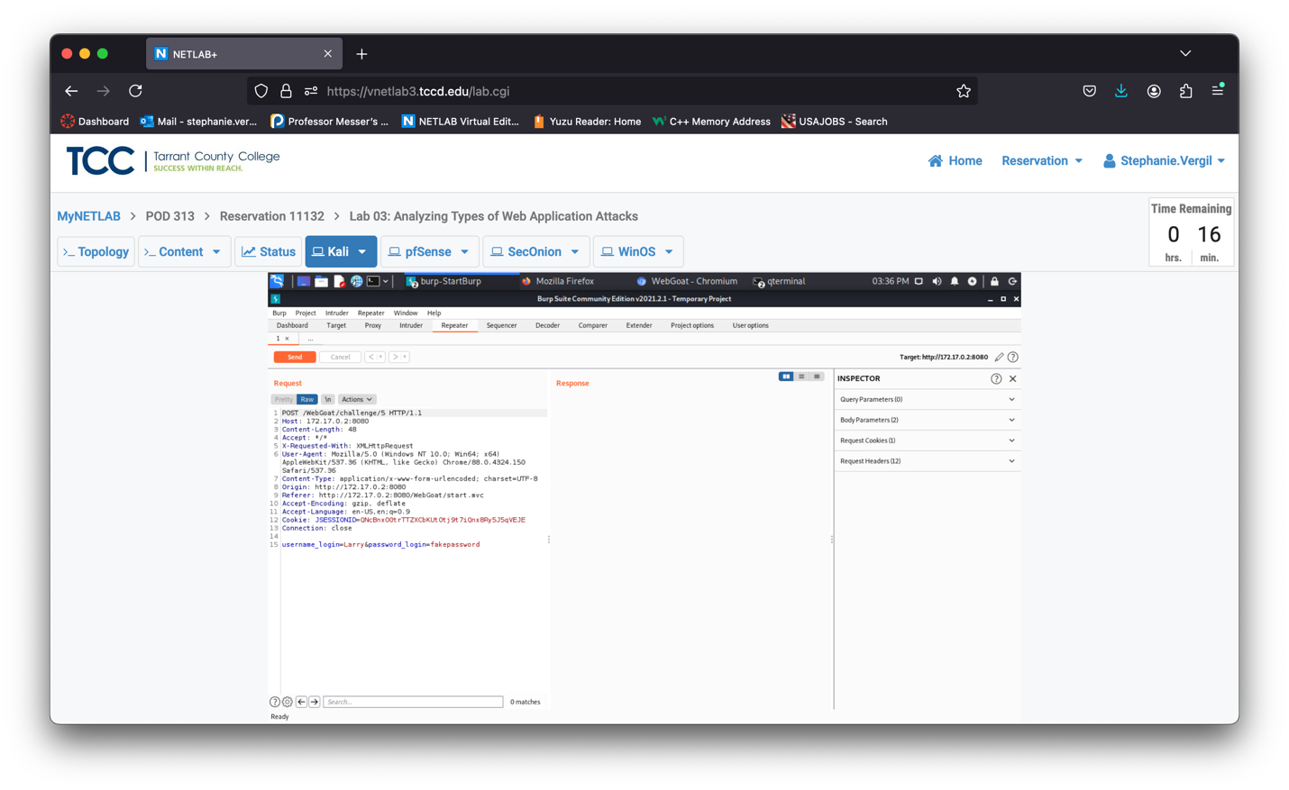

1. Repeater is a built-in function in Burp Suite; it functions like the Tamper Data add-on in Firefox you experienced in Lab 2. Here is how Repeater works. On the left side, the attacker could choose to change the content of the POST request, and then Send it to the server. The reply will be presented on the right side in the Response section. In our case, the username and the password we submitted earlier are shown at the bottom.
2. To exploit the SQL Injection, we just need to change our username or password fields and click Send. The result will show on the right side. Since the challenge is “Can you login as Larry?” we know that the username Larry must exist. So, we can manipulate the password field. Let’s click in the password_login field and replace the “fakepassword” text by typing the magic string: 0’ or 1=1, then click the Send button.

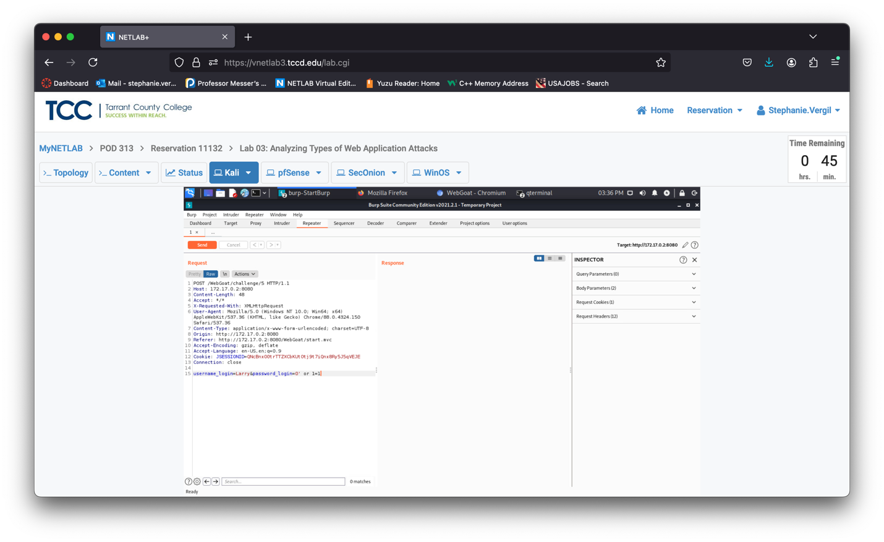

1. Unfortunately, our first try spawns an error. It did not go through.

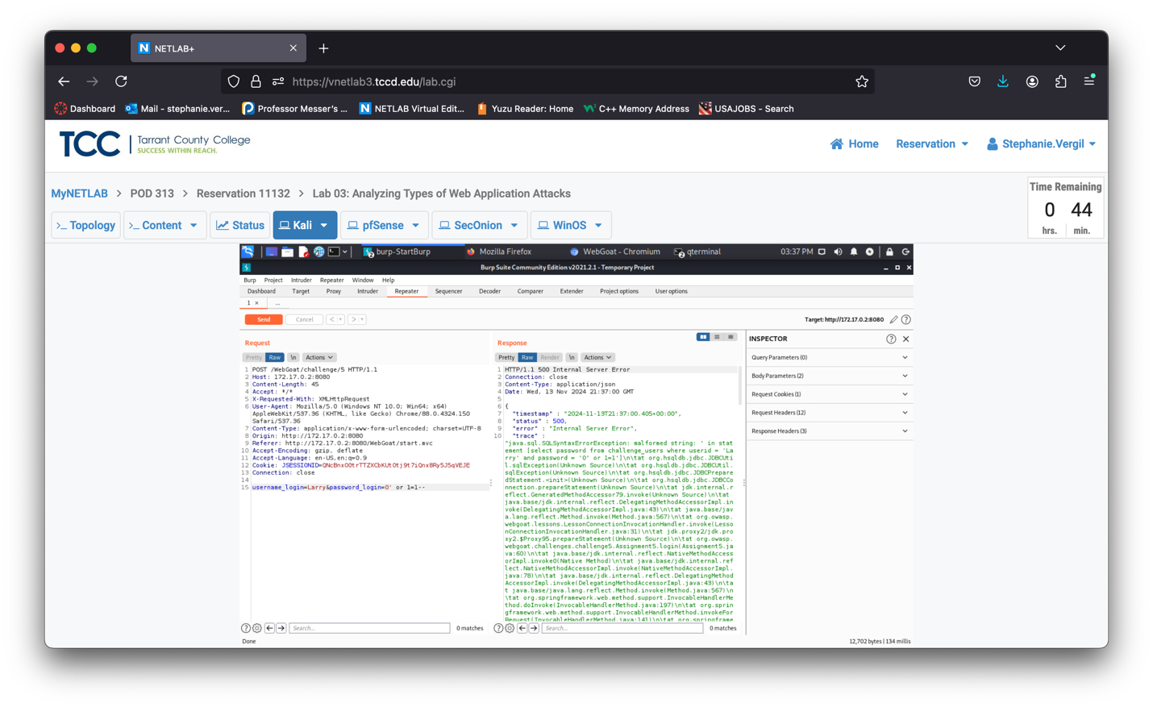

1. After a few retries, we learned that the “--” can play an important role when attacking with SQL Injection. The “--” will comment out everything after. Thus, the SQL injection query could be altered to ‘ or 1=1 –

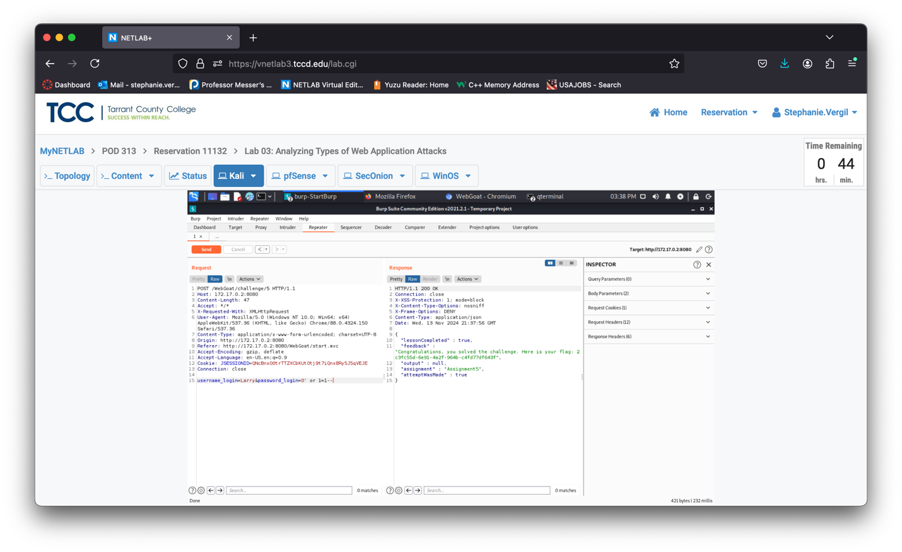

1. Feel free to submit the flag to the WebGoat website. This section ends here. You can close all windows. We will start a fresh Burp Suite and Terminal in the next section.
   1. Using DVWA for SQL Injection

In the previous section, you learned how to do the SQL injection manually. In this section, you will learn how to do SQL injection automatically using SQLmap.

1. Click on the SecOnion tab, then click and drag up to unlock the screen for a login prompt.
2. Type sysadmin as the username and NDGlabpass123! for the password.
3. Once logged in, click Applications > System Tools > Terminal to start the Terminal.
4. In the Terminal, enter the command: sudo docker run --rm -it -p 4444:80 vulnerables/web-dvwa When prompted, enter the password provided
5. When you see something like this, it means the dvwa server is up and running.

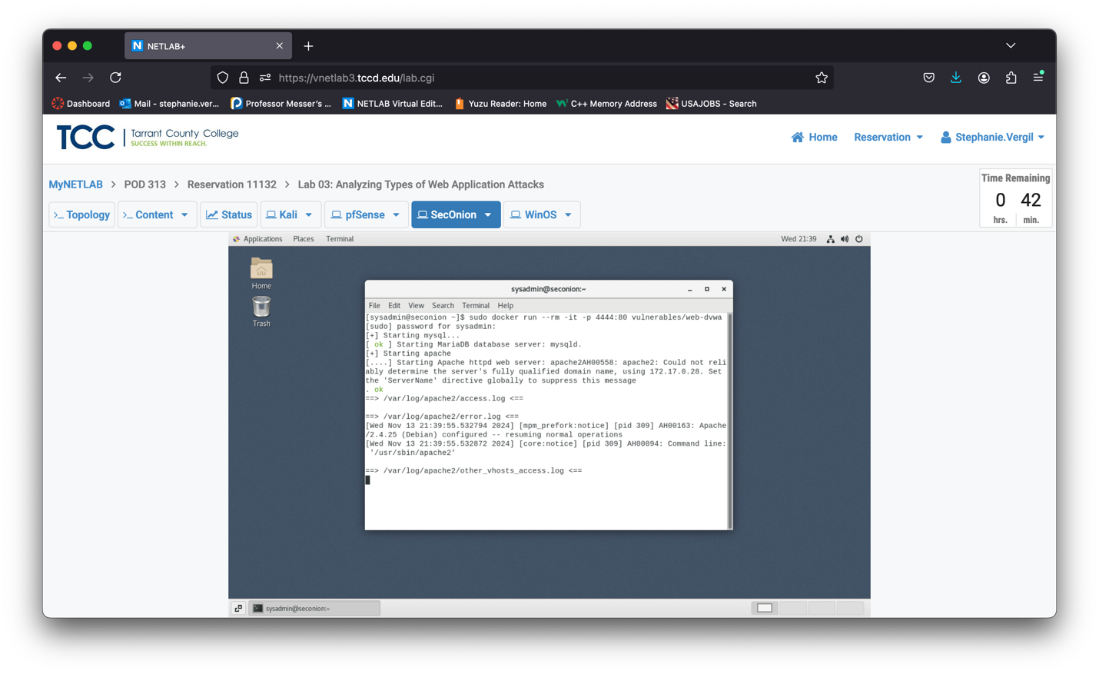

1. Click back on the Kali tab to switch back to the Kali machine. Before we can use SQLmap we have to prepare the vulnerable database. Open a web browser again. In the address bar, type <http://203.0.113.1>.
2. You will see the pfSense page; log in.

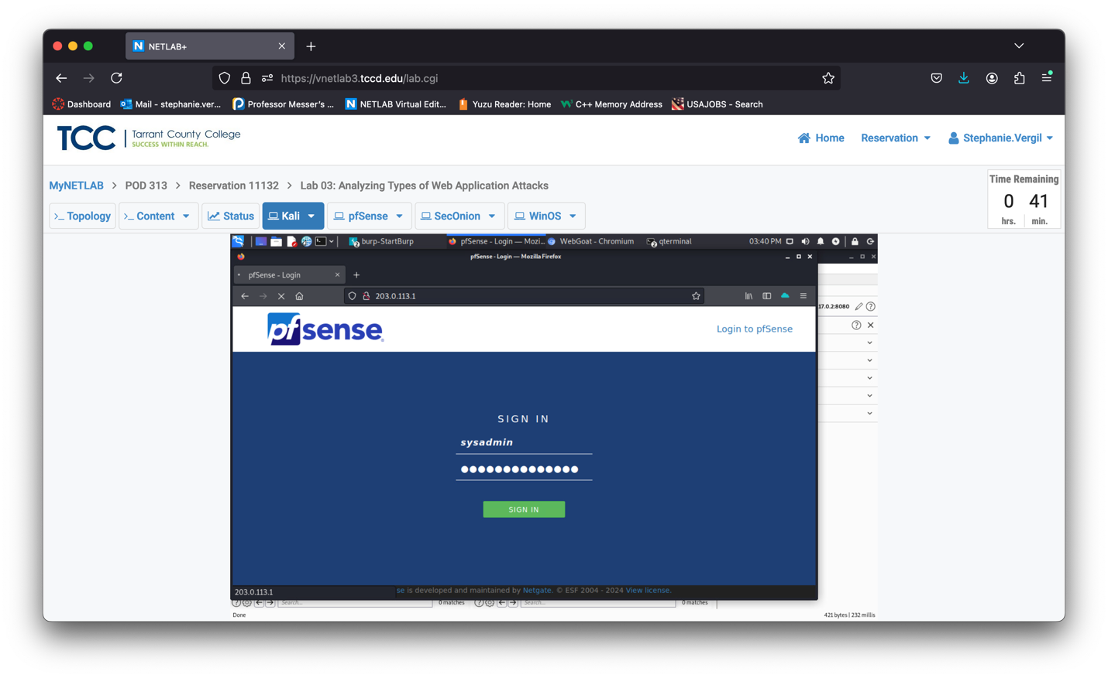

1. Once logged in, click the Firewall menu, and select the Rules option.
2. On the opened page, check to make sure you are on the WAN tab, and click the disable icon located on the right side of the first rule (Block Internal network access rule).
3. When it prompts that rule configuration has been changed, click Apply Changes to confirm the change. The first rule should grey out, and you can now access the internal network.

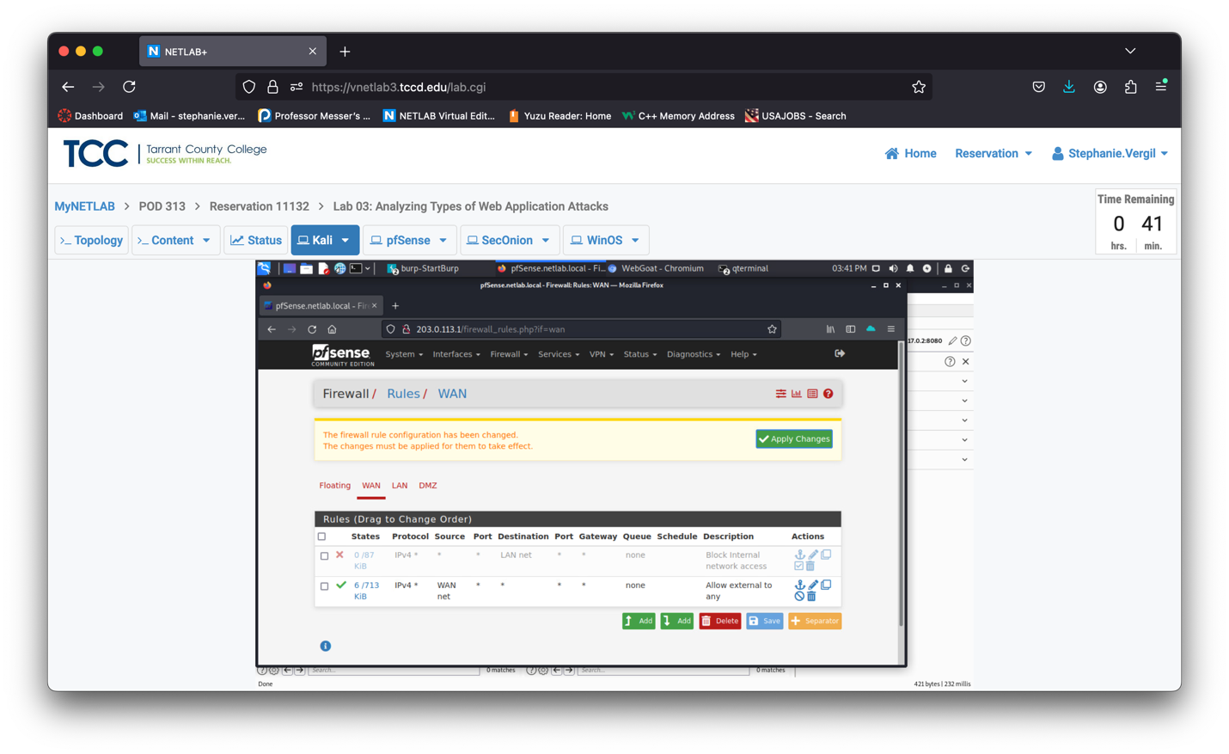

1. In the address bar, type <http://192.168.0.6:4444>.
2. Once the page opens, log in with the username admin, password admin.
3. On the new page, scroll down to the bottom. Click the Create/Reset Database button. It will log you out.
4. Log back in with the username admin, password password. When you see the Welcome page, you are all set. You can close the Firefox window.

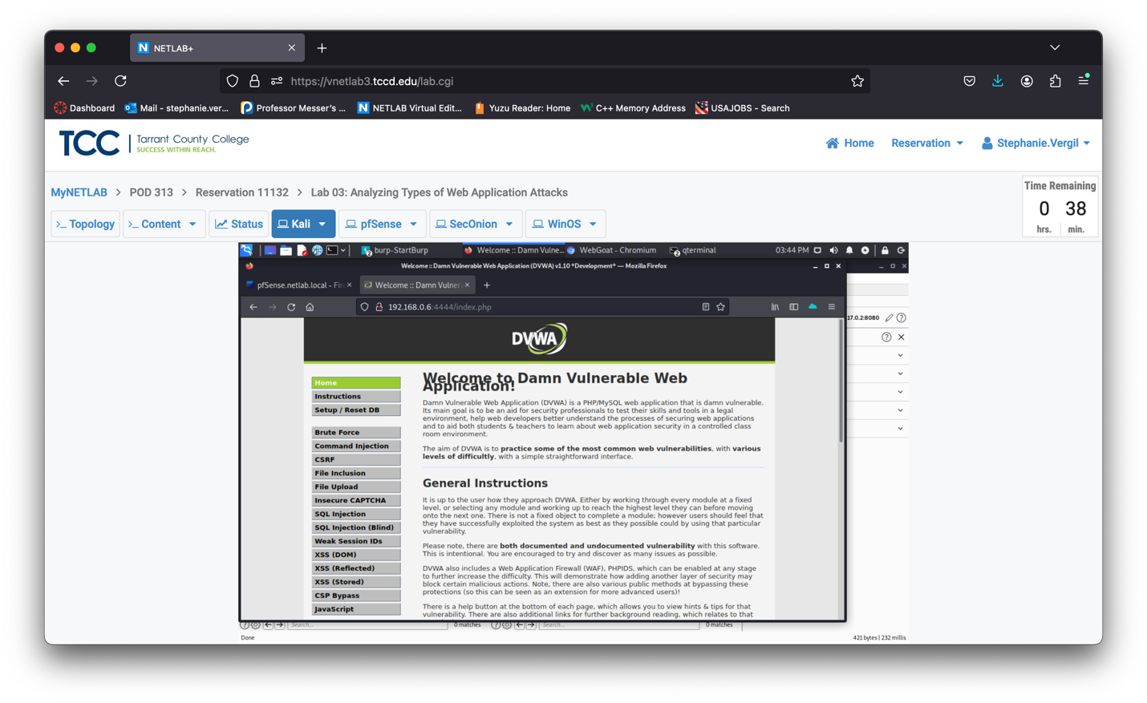

1. Now we will fire up Burp Suite once again to collect some information before we use SQLmap. Once again, go to the top-left corner, click the Application menu and type burpsuite, then click burpsuite to start the software
2. Click Next and Start Burp on the next two screens. (if Burp Suite prompts for an update, click Close, or if Burp Suite prompts to delete old temporary files, click Delete.)

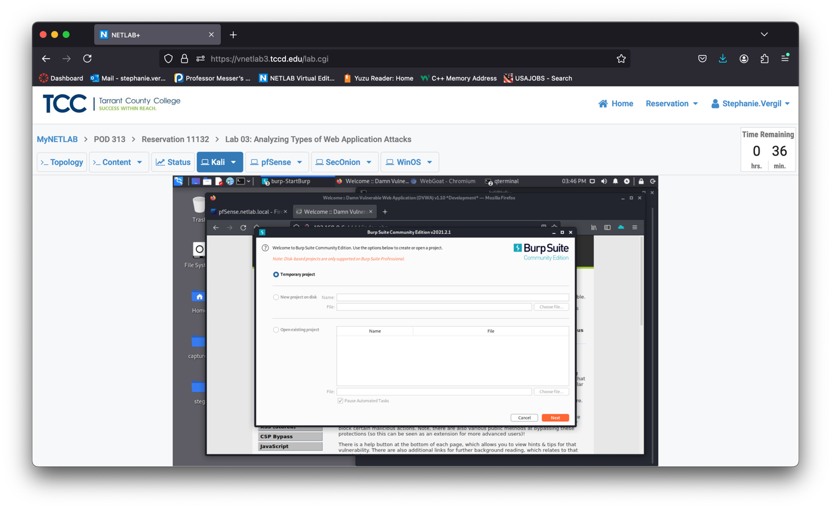

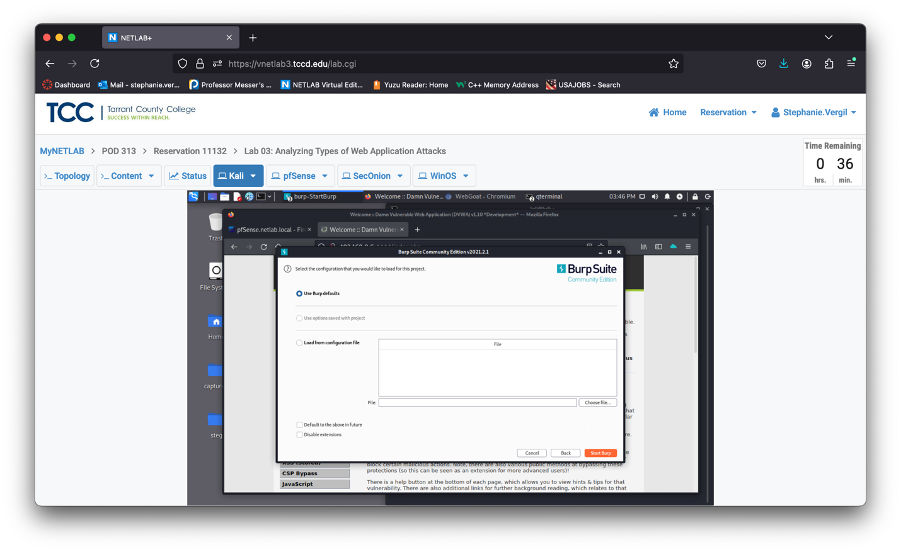

1. When Burp Suite starts, click Proxy to switch to the tab.
2. Then click Intercept is on to turn interception off for now (we will use it later). At last, click the Open Browser button.
3. In the newly opened browser, go to the http://192.168.0.6:4444
4. Log in as username admin, password password. When prompted to save the password, answer Never.
5. . Click SQL Injection on the next page
6. You will see the SQL Injection page
7. Go back to the Burpsuite window; you should still be at the Proxy tab. Click the Intercept is off button to turn it back on.

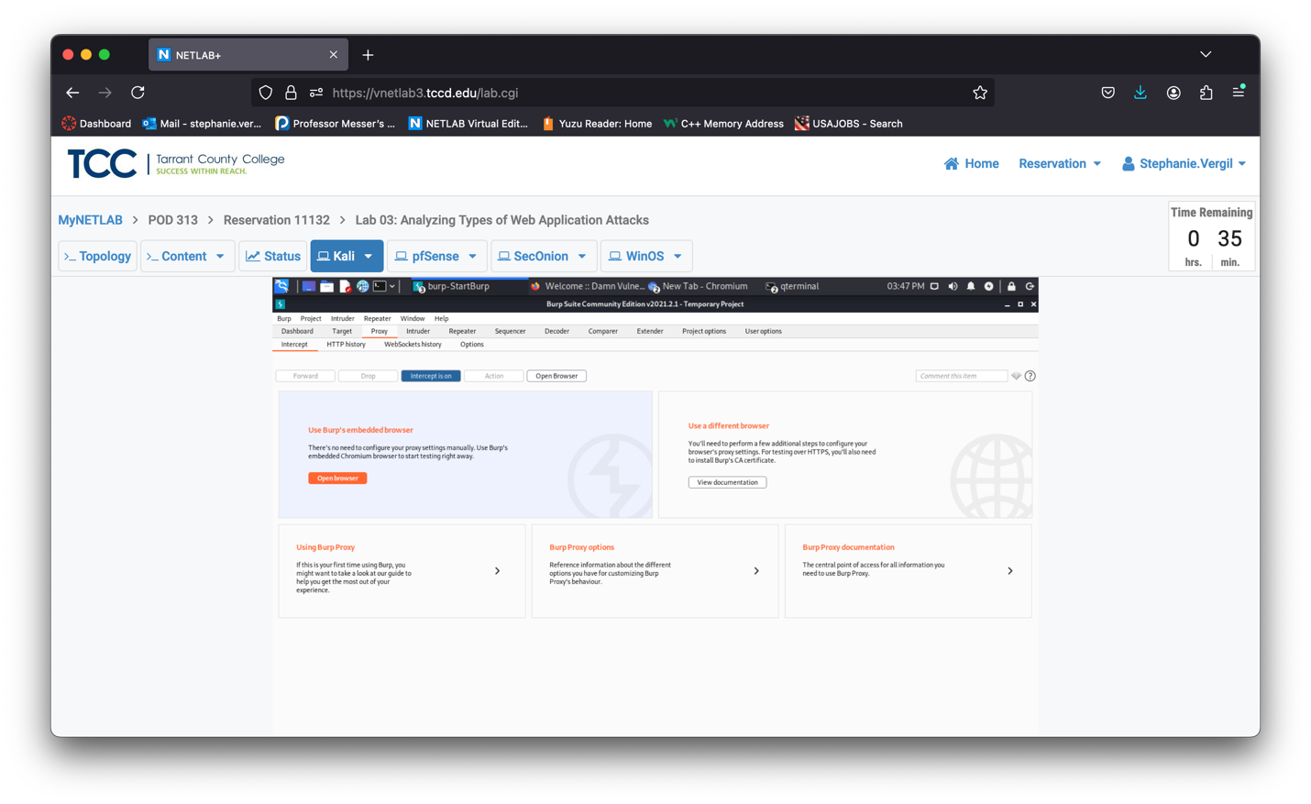

1. Then, switch back to the Vulnerability: SQL Injection window. We are going to type fakeid, and click Submit.
2. After you click the Submit button, it should bring you back to the Burpsuite window. We are going to need the following two pieces of information from this screen. Make a note of them.

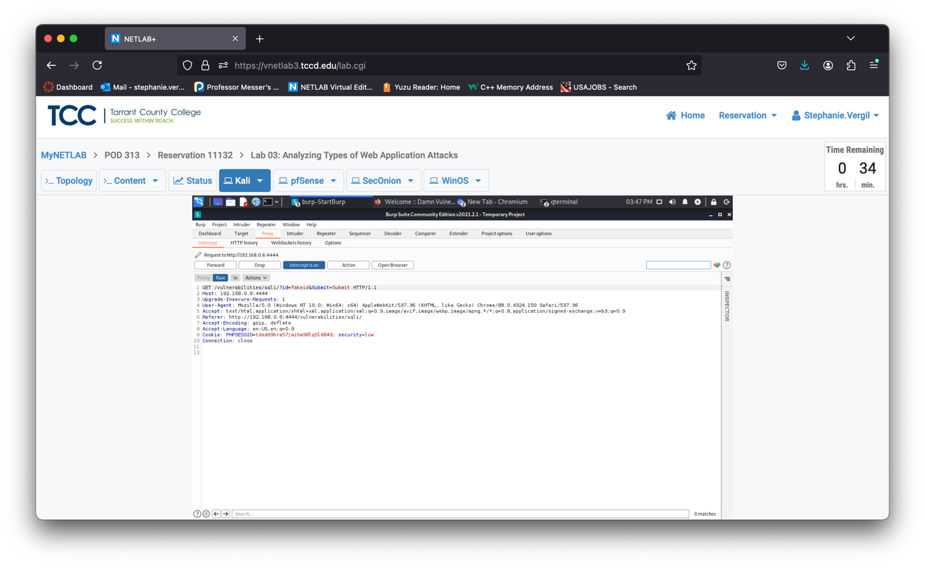

1. Once you have them written down, click the X button to close the Burp Suite window (if prompted to close all Burp Suite windows, answer Yes). The browser windows will close.
2. Click the Terminal icon to start the Terminal.
3. In the Terminal window, type the command below and press Enter to execute the command. sqlmap -u “http://192.168.0.6:4444/vulnerabilities/sqli/?id=fakeid&Submit=Submit” –cookie “PHPSESSID=tded69hra57jaiha981q516843; security=low” –dump
4. Type y for the question below, then press Enter.
5. Type y for the question below, then press Enter.

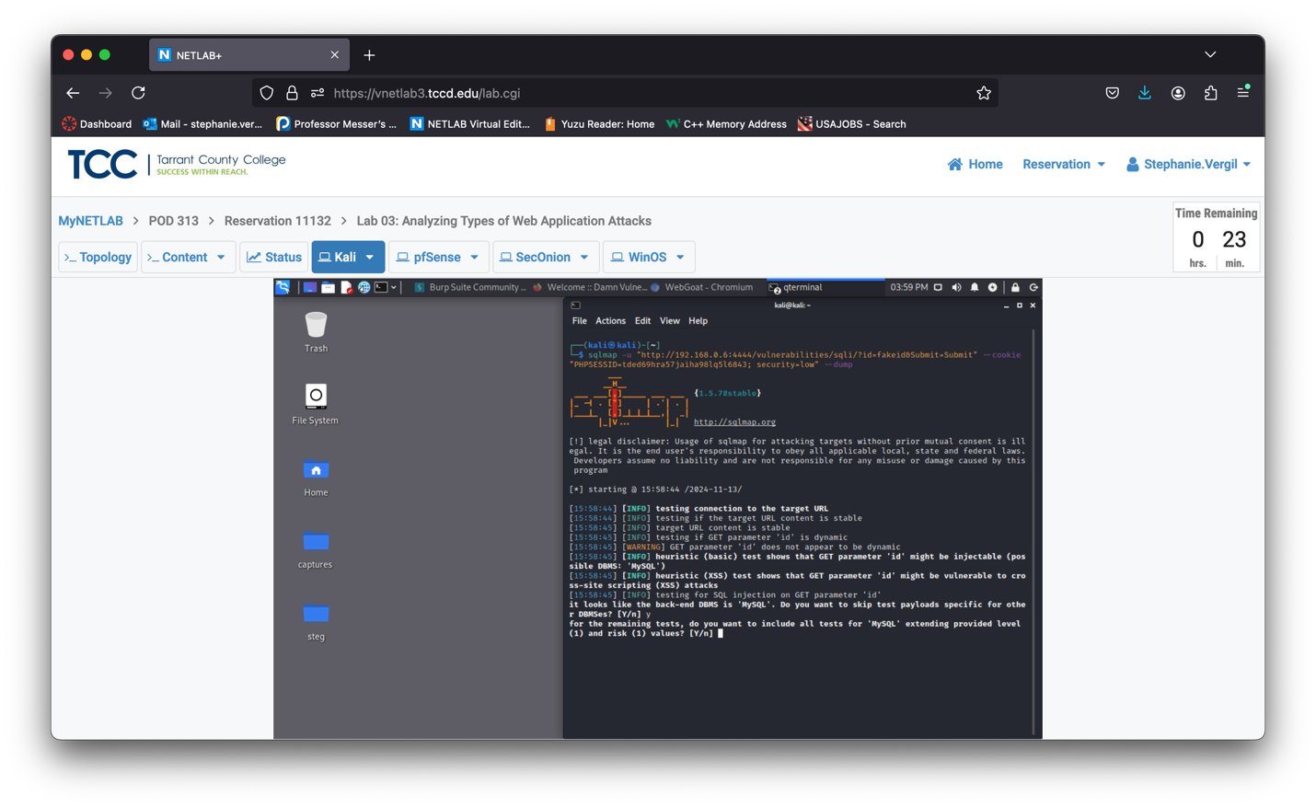

1. Type n for the question below, then press Enter.
2. Type y for the question below, then press Enter.
3. Type y for the question below, then press Enter.

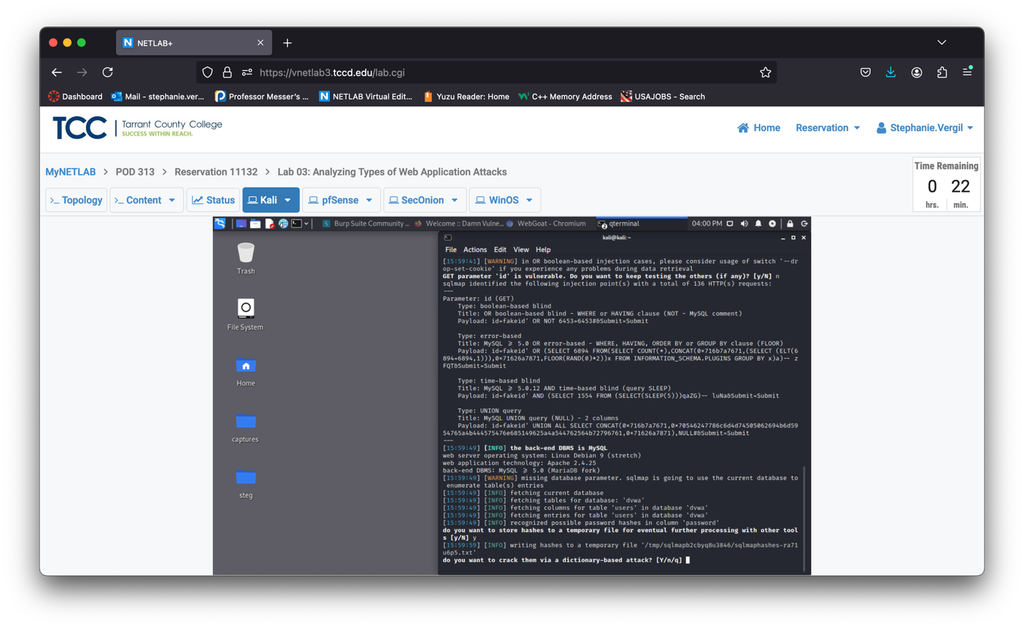

1. Simply press Enter to use the first option.

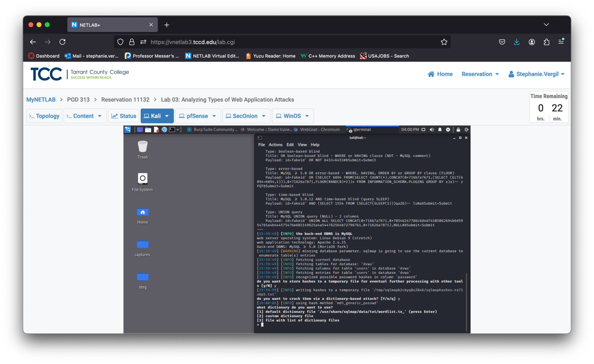

1. Type n for the question below, then press Enter.

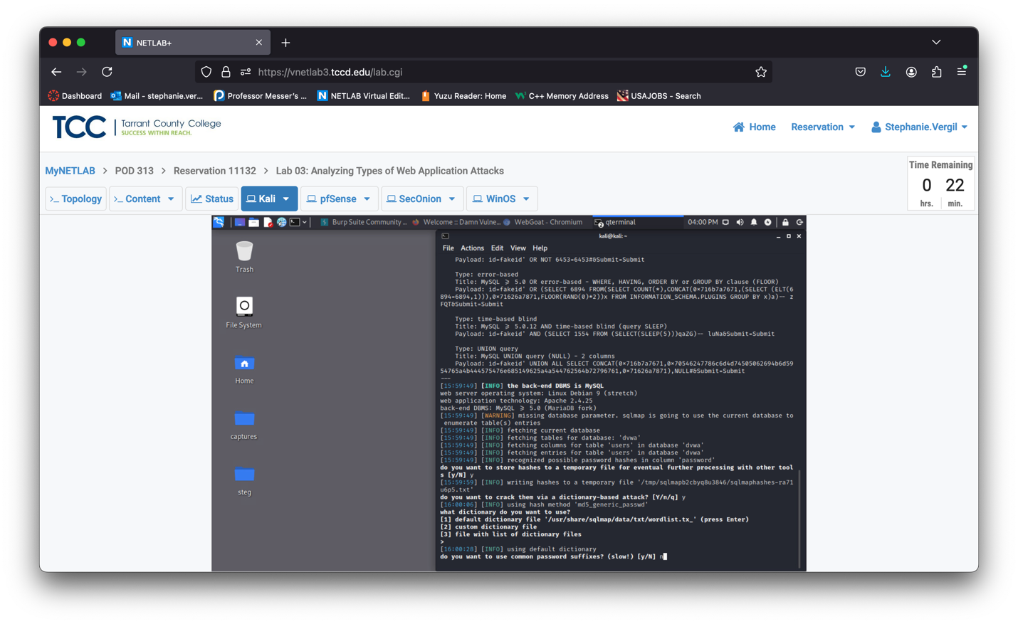

1. Wait till it finishes the SQL injection attack. Scroll up the Terminal window, until you see something like this. The rectangle indicates the place where the dumped database was stored.

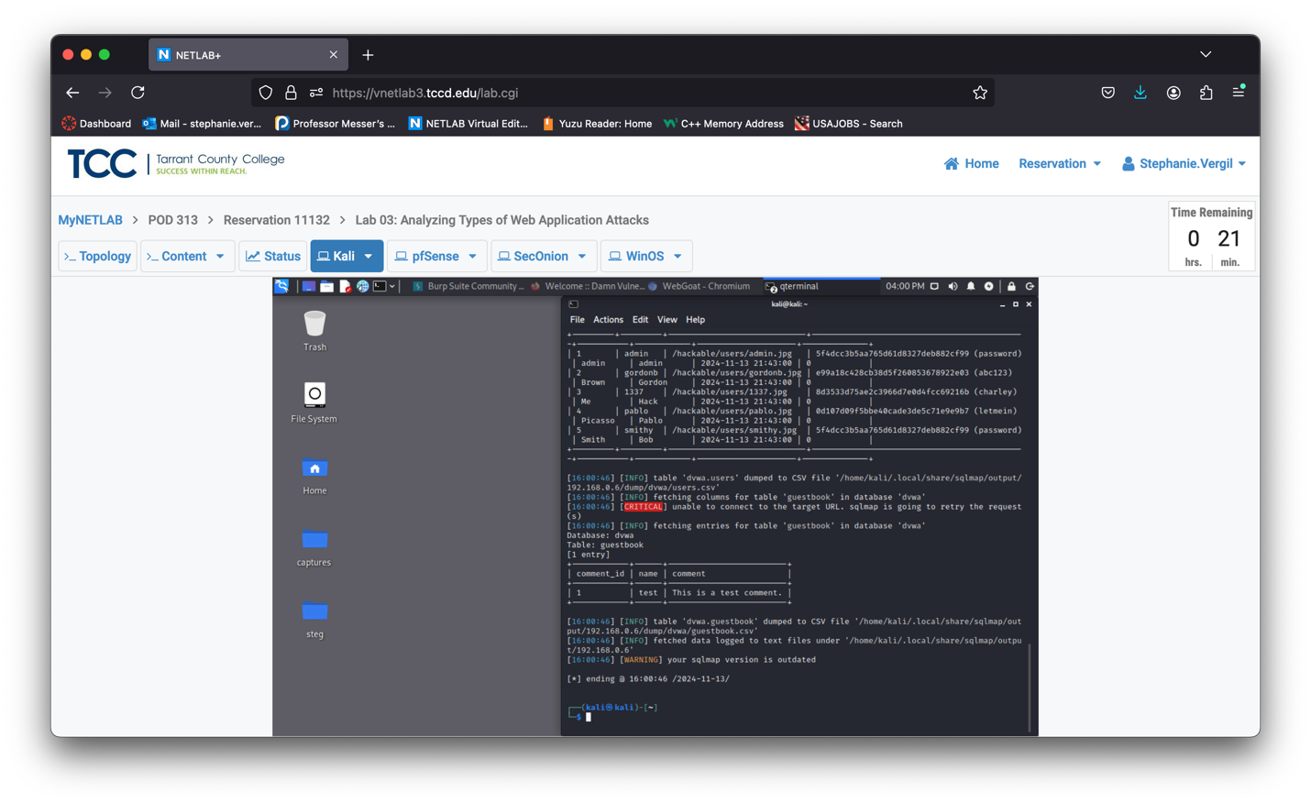

1. Run the command below to have a better view of what is inside the table:

csvtool readable /home/kali/.local/share/sqlmap/output/192.168.0.6/dump/dvwa/users.csv

1. The results of the command will look like this. The passwords are stored in the database as hashes. Since the SQLmap decrypted all of them, you see the cracked hashes in the parenthesis.

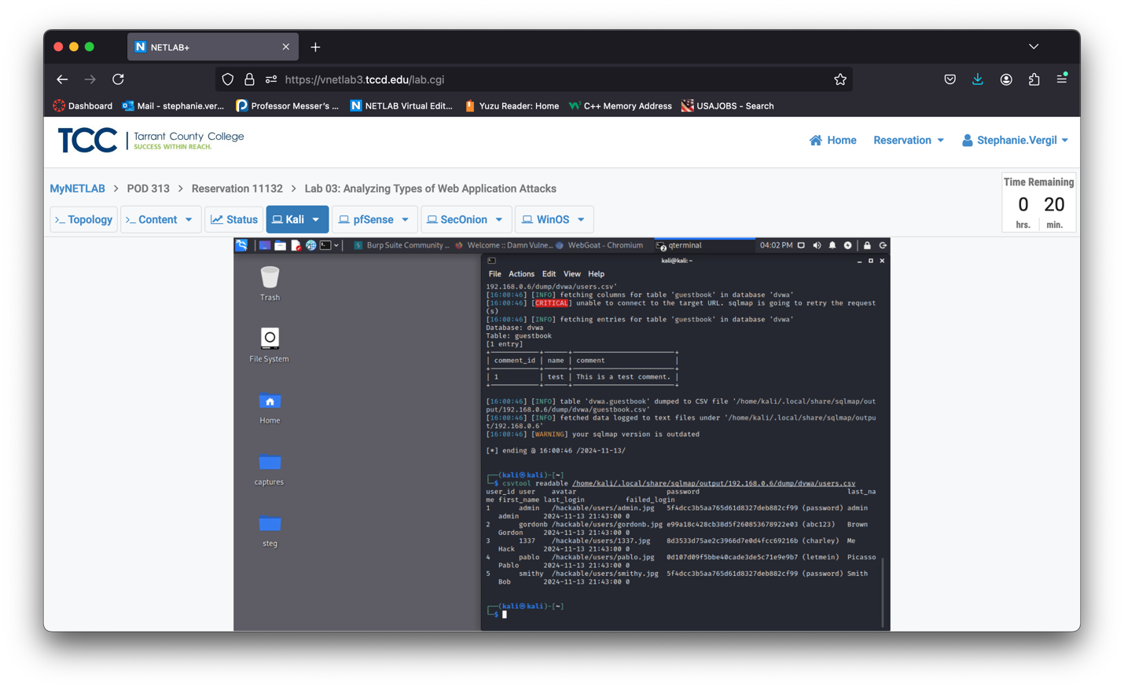

1. Lab completed.